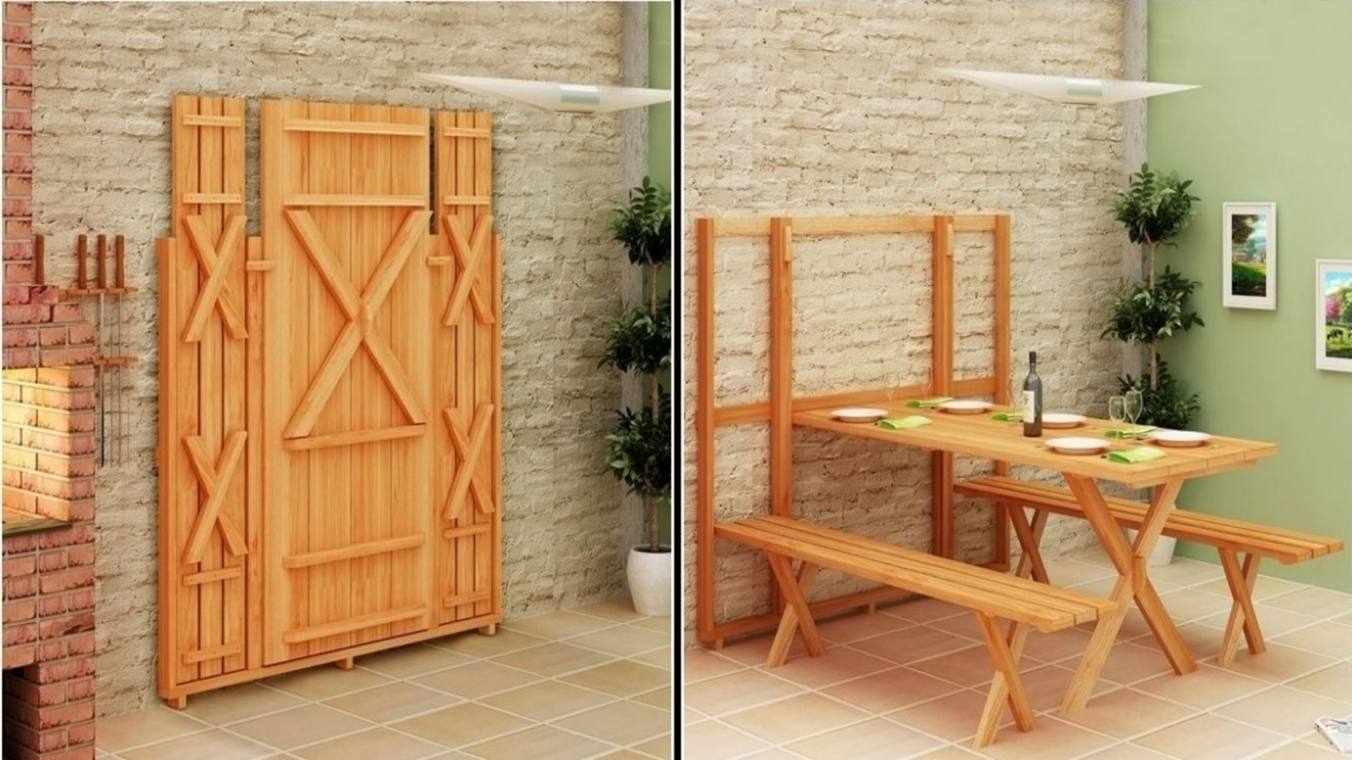

|  |  |
| --- | --- |
| **Title** | Wall-hanged Outdoor Table And Chairs |
| **Size** | 1.5 m long ; 1.2 m wide; 1.3 m high |
| **Weight** | 135 kg |
| **Price** | $1,050.00 |